**SQL RESTAURANT ORDERS ANALYSIS**

**1--View the menu_items table and write a query to find the number of items on the menu—**

Select COUNT(item_name) From menu_items;

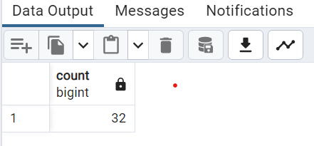

**--2 What are the least and most expensive items on the menu?*/\***

Select item_name, price

From menu_items

Order By price ASC

LIMIT 1;

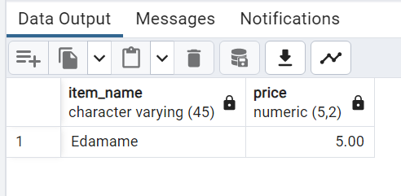

Select item_name, price

From menu_items

Order By price DESC

LIMIT 1;

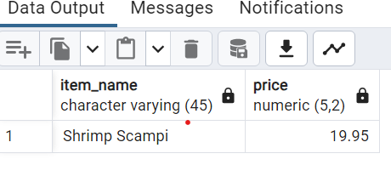

**3--How many Italian dishes are on the menu? What are the least and most expensive Italian dishes on the menu?*/**

SELECT COUNT(*) AS Italian_dishes

FROM menu_items

WHERE category ='Italian';

--Least dishes--

SELECT item_name, price, category

FROM menu_items

WHERE category = 'Italian'

ORDER BY price ASC

LIMIT 1;

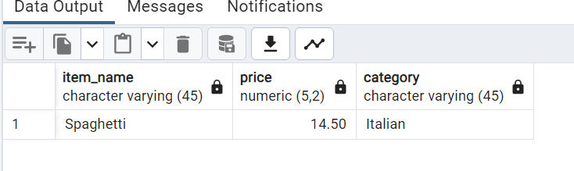

---Expensive dishes--

SELECT item_name, price, category

FROM menu_items

WHERE category = 'Italian'

ORDER BY price DESC

LIMIT 1;

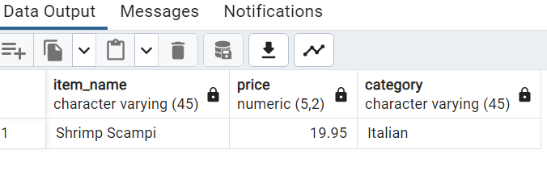

**4/*How many dishes are in each category? What is the average dish price within each category?*/**

SELECT category,count(*)AS dish_count

FROM menu_items

GROUP BY category;

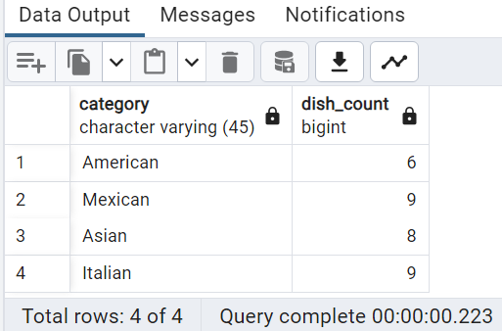

**--Average dish--**

SELECT category,ROUND(AVG(price), 2) AS Avg_Dish

FROM menu_items

GROUP BY category;

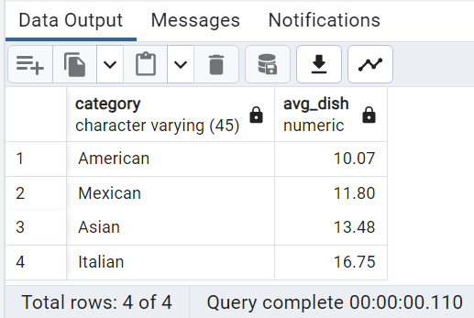

**5/*View the order_details table. What is the date range of the table?*/**

SELECT Min(order_date) min_date, Max(order_date)AS max_date

FROM order_details;

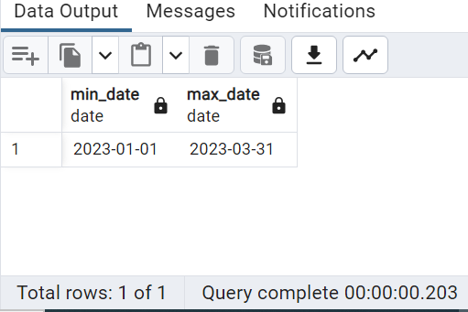

**6/*How many orders were made within this date range?*/**

SELECT Distinct count(order_id) AS total_orders FROM order_details

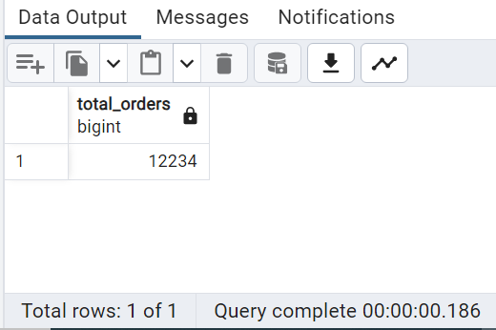

**7/*How many items were ordered within this date range?*/**

SELECT menu_item_id, COUNT(item_id)

FROM menu_items

JOIN order_details

ON menu_item_id = item_id

Group By menu_item_id;

SELECT COUNT (item_id) AS TOtal_item_ordered

FROM order_details;

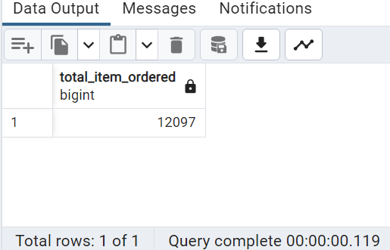

**8--Which orders had the most number of items?--**

Select order_id, COUNT(item_id)

from order_details

GROUP BY order_id

ORDER BY Count(item_id) DES;

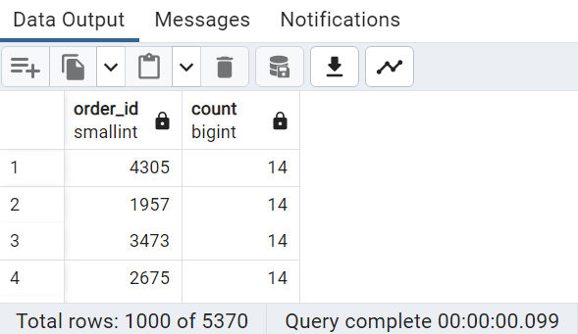

**9 --How many orders had more than 12 items?--**

SELECT order_id, Count(item_id)

FROM order_details

Group By order_id

Having Count(item_id)> 12

Order By Count(item_id)DESC;

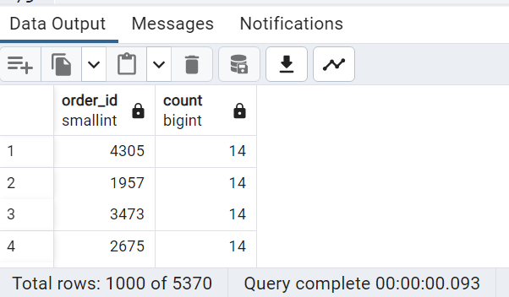

**10--How many orders had more than 12 items?--**

SELECT order_id, Count(item_id)

FROM order_details

Group By order_id

Having Count(item_id)> 12

Order By Count(item_id)DESC;

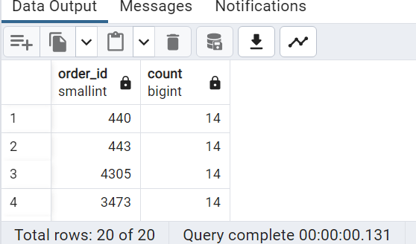

**11--Combine the menu_items and order_details tables into a single table--**

SELECT * FROM menu_items m

INNER JOIN order_details o

ON m.menu_item_id = o.item_id;

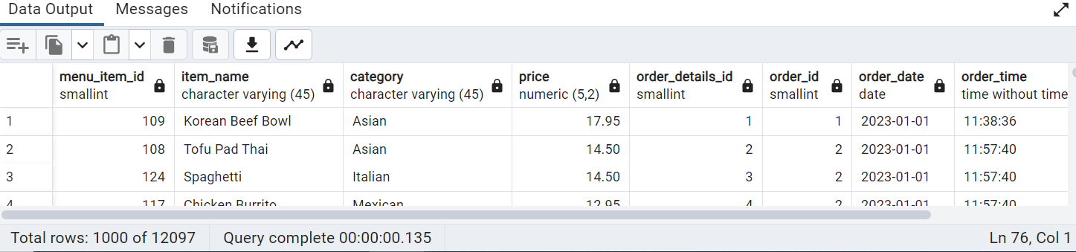

**12--What were the least and most ordered items? What categories were they in?--**

SELECT m.category, m.item_name, COUNT(o.order_id)

FROM menu_items m

JOIN order_details o

ON m.menu_item_id = o.item_id

GROUP BY m.category, m.item_name

ORDER BY COUNT(order_id)ASC

FETCH FIRST 5 ROWS ONLY;

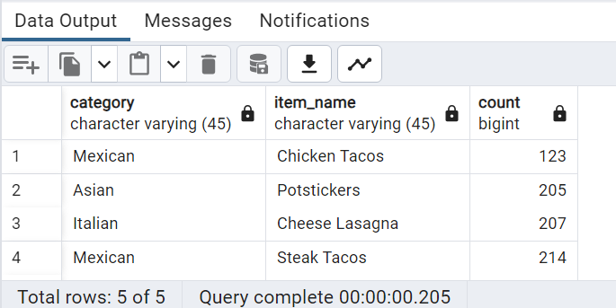

**---IN DECENDING ORDER---**

SELECT m.category, m.item_name, COUNT(o.order_id)

FROM menu_items m

JOIN order_details o

ON m.menu_item_id = o.item_id

GROUP BY m.category, m.item_name

ORDER BY COUNT(order_id) DESC

FETCH FIRST 5 ROWS ONLY;

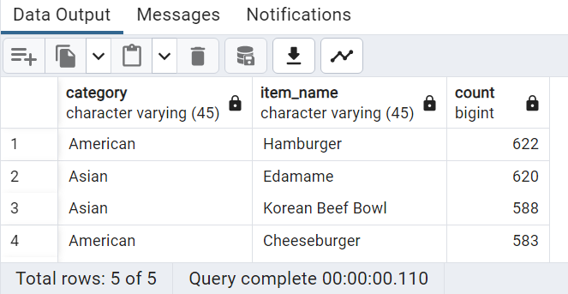

**13--What were the top 5 orders that spent the most money?--**

SELECT o.order_id, SUM(m.price)

FROM menu_items m

JOIN order_details o

ON m.menu_item_id = o.item_id

GROUP BY order_id

ORDER BY SUM(price)DESC

FETCH FIRST 5 ROWS ONLY;

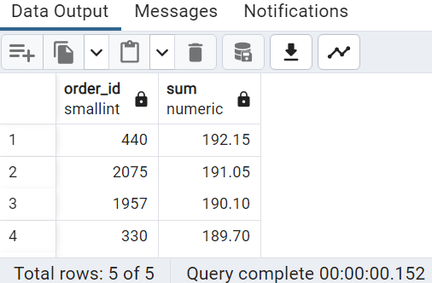

**14--View the details of the highest spend order. Which specific items were purchased?--**

SELECT * FROM menu_items m

JOIN order_details o

ON m.menu_item_id = o.item_id

WHERE order_id =440;

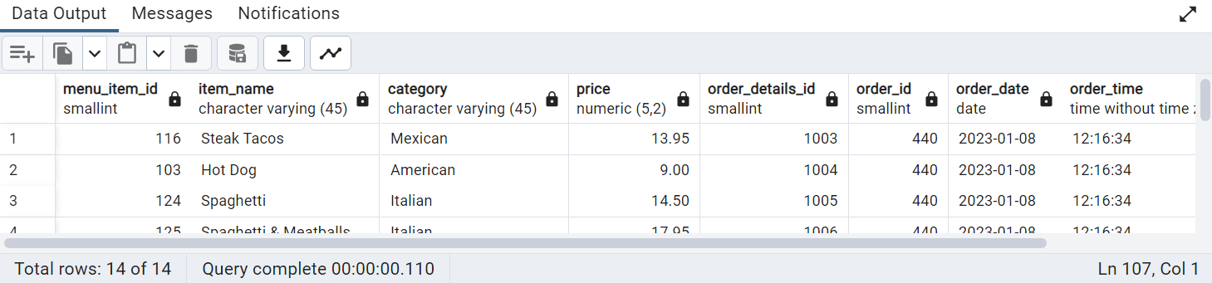

**15--View the details of the top 5 highest spend orders--**

SELECT *

FROM menu_items m

JOIN order_details o

ON m.menu_item_id = o.item_id

WHERE order_id IN(440,2075,1957,330,2675);

